ENPM680 Final Project: Phase 2
RetroBytes - A Place for Retro and
Vintage Items

By
Name | Sai Praneeth Koti
Email | ksp@umd.edu
Directory ID | ksp
UID | 121297495

Table of Contents
1. Application Overview 3
2. System Architecture 6
3. Application Software Components 10
4. Application UI Components 14
5. Application Data Components 19
6. Test cases 26
7. Traceability 29
8. References 30

List of Figures
Figure 1 Web Application High Level Flow 4
Figure 2 UML Class Diagram (Retro Bytes) 9
Figure 3 Layered Architecture 9
Figure 4 Simple Navigation Map 16
Figure 5 Category Listing 16
Figure 6 Product Details 17
Figure 7 Cart 17
Figure 8 Wishlist 18
Figure 9 Checkout 18
Figure 10 Admin Inventory 18

1. Application Overview

1.1 High-level description:
Retro Bytes is a small e-commerce website that is made for people who love retro style products. The site mainly gives a collection of nostalgic items such as retro shoes, vintage radios, old-style electronics, and classic gaming consoles. The design is kept very light and user-friendly, so customers can easily browse and enjoy the shopping experience. The focus is more on showing retro products in a clear way rather than giving too many extra features.
Customers can browse products by category and view full product details and condition (first-hand or second-hand) with price and images and also check local stock by postal code and then add items to cart and complete a simple checkout in a clean, lightweight web application focused on retro items.
1.2 Technology stack:
Application will be built on Go Fiber v2 or Go.
- Web framework: gofiber/fiber v2
- Templates (server-rendered pages): html/template
- Database: Relational database such as SQLite (dev)
- Image upload/storage (admin): store under /media, generate safe filenames
- Container multi-stage Dockerfile and DevContainer for VS Code

1.3 Overall Architecture Approach:
1.3.1 Architecture Style: We will use a simple layered architecture with clear separation of concerns. This makes every feature map neatly to our use cases and functional requirements and it also helps the system scale later without major code rewrites.
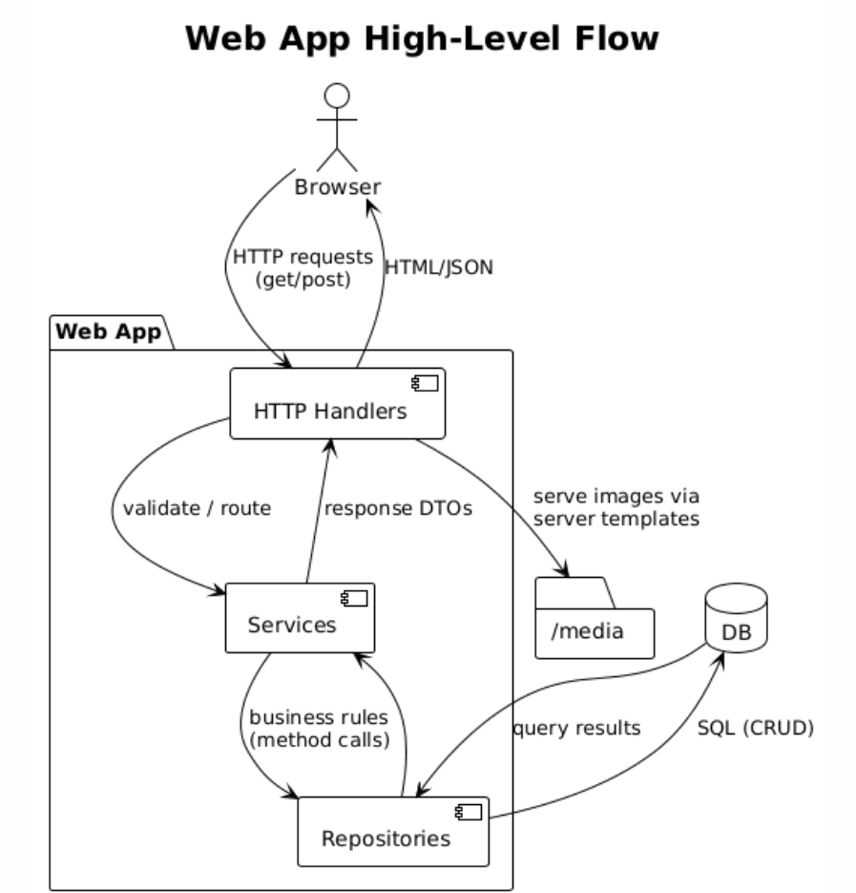
Figure 1 Web Application High Level Flow

1.3.2 Key Responsibilities
- Handlers (HTTP): Validate inputs, call services, choose views or templates or JSON responses.
- Services: Implement Functional Requirements such as stock lookup, cart math, order placement, search or filter and wishlist.
- Repositories: Encapsulate SQL and return domain models i.e. no SQL in handlers or services.
- Templates or UI: Server rendered pages such as Home, Category, Product, Search, Cart, Checkout, Confirmation, Wishlist and Admin.
- Media: Admin image uploads stored under /media with DB references such as filename and alt text.

1.3.2 Functional requirements
- FR-001/002 -> Category or Product handlers -> CatalogService-> Product or Category repos.
- FR-003/004 -> Inventory handler -> InventoryService -> Inventory repo.
- FR-005/006/007 -> Cart or Order handlers -> Cart or Order services -> Cart/Order/Inventory repos.
- FR-008/009 -> Search handler -> Search or Catalog services -> Product repo.
- FR-010 -> Wishlist handler -> WishlistService -> Wishlist repo.
- FR of Admin -> Admin handlers -> Catalog or Inventory services -> repos
1.3.3 Layered Architecture
1 Presentation Layer
- Web pages & minimal JS rendered via templates such as Home/Category, Product Detail, Search/Filters, Cart, Checkout, Wishlist, Admin pages.
- HTTP endpoints that accept requests and return HTML/JSON.
- Responsibilities: The handler will collect user inputs like search text, ZIP code, and quantity, and do basic validation for format and required fields. It will decide whether to return a template view or a JSON response and show clear user messages for empty results or errors. It will not contain any business rules or SQL, keeping the logic clean and separate.
- Key components such as Handlers: CategoryHandler, ProductHandler, InventoryHandler, CartHandler, OrderHandler, WishlistHandler, AdminHandlers.
- Functional Requirements coverage examples: FR-001/002 (browse & product page), FR-003/004 (availability UI), FR-005/006/007 (cart/checkout screens), FR-008/009 (search/filters), FR-010 (wishlist UI).
2 Application Layer
- Services that implement the rules of the domain and orchestrate multiple repos.
- Responsibilities: The service layer will apply business rules such as computing stock status (IN/LOW/OUT), capping quantity to available stock, calculating order totals, keeping correct wishlist behavior, paginating results, and preparing clean view models. It will also coordinate multiple repositories such as creating an order together with reserving stock. It will expose clear methods to the handlers, with no HTTP handling or SQL inside this layer
- Key components includes Services: CatalogService, InventoryService, CartService, OrderService, WishlistService + Admin operations through Catalog/Inventory services.
- Functional Requirements coverage examples: FR-004 (status calculation), FR-005 (cart math), FR-007 (reserve stock then create order), FR-008/009 (search + filter logic).

3 Data Layer
- Repositories that encapsulate all SQL/queries and persistence details.
- Database (SQLite dev) and /media for product images.
- Responsibilities: Provide CRUD methods such as FindProductsByCategory, GetProduct, GetQtyByRegion, UpsertCartItem, CreateOrder, etc. and keep SQL/indexing/pagination details hidden behind repo interfaces.
- Key components consist repos: ProductRepo, CategoryRepo, InventoryRepo, CartRepo, OrderRepo, WishlistRepo.
- Storage: DB (tables for products/categories/inventory/carts/orders/wishlists) + /media (image files; paths stored in DB).
- Functional Requirements coverage examples: FR-001/002 (fetch lists/details), FR-004 (lookup qty by product+region), FR-005/006/007 (persist cart/items/order), FR-010 (persist wishlist).

2. System Architecture
2.1 Components and their connections
2.1.1 Client side web browser: Renders server-generated pages such as Home/Category, Product, Search, Cart, Checkout, Wishlist, Admin. Minimal JS for form submits, pagination and small UI updates.

2.1.2 HTTP Layer (Handlers):
- CategoryHandler, ProductHandler, InventoryHandler, CartHandler, OrderHandler, WishlistHandler
- AdminHandlers such as Products, Categories and Inventory.
- Responsibilities: validate request inputs, call Services, choose template or JSON response.

2.1.3 Service Layer (Business Logic):
- CatalogService, InventoryService, CartService, OrderService, WishlistService
- Responsibilities: implement Functional Requirement logic such as stock checks, cart math, order placement, search/filter to compose data from multiple repos.

2.1.4 Repository Layer (Data Access):
- ProductRepo, CategoryRepo, InventoryRepo, CartRepo, OrderRepo, WishlistRepo
- Responsibilities: all SQL/queries which return domain models to Services.

2.1.5 Storage:
- Database: SQLite for development.
- Media: /media directory for product images. DB stores file paths/metadata.

2.2 Data Flow Between Components
A) Browse Catalog (FR-001/FR-002)
- Browser requests /category/{id} > CategoryHandler
- Handler calls CatalogService > ProductRepo/CategoryRepo
- Repos query DB, return products & category info
- Service returns view model > Handler renders Category page (thumbnails, title, price, condition)
- Product click: /product/{id} follows the same path via ProductHandler, plus image paths from DB to the template where the images load from /media.
B) Check Local Stock (FR-003/FR-004)
- On Product page, user enters ZIP > InventoryHandler (/availability?productId&region)
- Handler > InventoryService > InventoryRepo
- Repo queries DB for (productId, region) > qty
- Service computes IN_STOCK / OUT_OF_STOCK + ETA
- Handler returns JSON > UI shows banner and enables Add to Cart if available.

C) Add to Cart & Checkout (FR-005/FR-006/FR-007)
- Add to Cart: Browser POST /cart { productId, qty } > CartHandler > CartService > CartRepo (persist) > return cart summary
- Checkout: Browser GET /checkout > Order summary page (from CartService/CartRepo)
- Place Order: POST /orders with items, region, contact > OrderHandler > OrderService
  - OrderService asks InventoryService to reserve stock (> InventoryRepo/DB)
  - On success, OrderRepo creates order; returns orderId
- Confirmation page renders with orderId, items, totals.
D) Search & Filter (FR-008/FR-009)
- Browser GET /search?q=...&category&condition&page > Search (Catalog) Handler
- Handler > CatalogService > ProductRepo (text match + filters + pagination)
- Results + counts returned. Handler renders list with active filters.
E) Wishlist (FR-010)
- Save/Unsave: Browser POST /wishlist or DELETE /wishlist/{productId} > WishlistHandler > WishlistService > WishlistRepo
- View: GET /wishlist returns items with current availability flags (optional quick check via InventoryService).
F) Admin CRUD
- Products/Categories: Admin pages call AdminHandlers > CatalogService > ProductRepo/CategoryRepo
- Inventory: Admin sets qty per (productId, region) via InventoryRepo
- Images: Admin upload posts to AdminHandlers which store files in /media and write paths to ProductRepo.

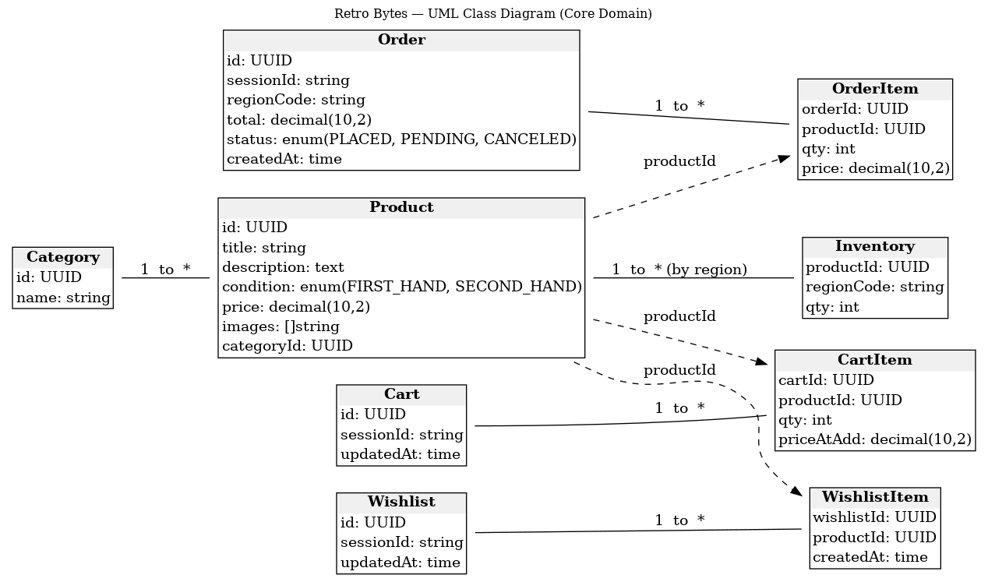
Figure 2 UML Class Diagram (Retro Bytes)

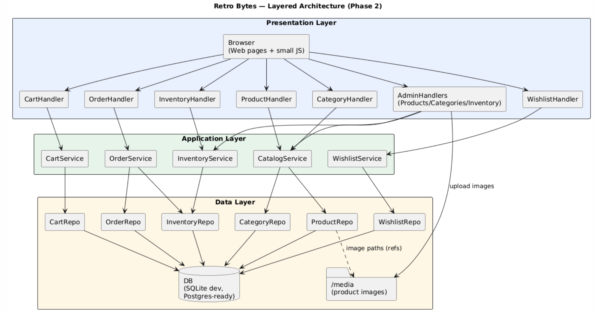
Figure 3 Layered Architecture

3. Application Software Components

3.1 Domain Classes / Models:
- Category: id, name
- Product: id, categoryId, title, description, condition {FIRST_HAND|SECOND_HAND}, price, images[]
- Inventory (by region): productId, regionCode, qty
- Cart: id, sessionId, updatedAt
- CartItem: cartId, productId, qty, priceAtAdd
- Order: id, sessionId, regionCode, total, status {PLACED|PENDING|CANCELED}, createdAt
- OrderItem: orderId, productId, qty, price
- Wishlist: id, sessionId, updatedAt
- WishlistItem: wishlistId, productId, createdAt

3.2 HTTP Handlers (Delivery / Presentation)
CategoryHandler – list categories, list products in a category
- Routes: GET /, GET /category/{id}
ProductHandler – product details
- Route: GET /product/{id}
InventoryHandler – availability by ZIP/region
- Route: GET /availability?productId&region
SearchHandler – keyword search + filters
- Route: GET /search?q&category&condition&page
CartHandler – view/add/update cart
- Routes: GET /cart, POST /cart, PATCH /cart/items/{productId}
OrderHandler – checkout & place order
- Route: POST /orders
WishlistHandler – save/unsave/list wishlist
- Routes: GET /wishlist, POST /wishlist, DELETE /wishlist/{productId}
AdminHandlers – CRUD for products/categories/inventory
- Routes: /admin/products, /admin/categories, /admin/inventory, image upload to /media

3.3 Services
• CatalogService
- Responsibilities: category listing, product listing by category, product detail, simple text search + filter merge and pagination.
- Key methods:
  - ListCategories() []Category
  - ListProductsByCategory(catID, page, sort) ([]Product, PageMeta)
  - GetProduct(id) Product
  - Search(query, category?, condition?, page) ([]Product, Counts, PageMeta)
• InventoryService
- Responsibilities: validate ZIP/region, compute IN/LOW/OUT, optional ETA rules and reserve stock for orders.
- Methods:
  - CheckAvailability(productID, region) Availability{status, qty?, eta?}
  - Reserve(items[], region) (ok bool, conflicts[])
• CartService
- Responsibilities: create/load cart, add/update/remove items, cap qty to stock, totals math.
- Methods:
  - GetCart(sessionID) CartSummary
  - AddItem(sessionID, productID, qty) CartSummary
  - UpdateQty(sessionID, productID, qty) CartSummary
• OrderService
- Responsibilities: validate checkout input, compute final totals, call InventoryService, Reserve, create order, clear/convert cart.
- Methods:
  - PlaceOrder(sessionID, region, contact, items[]) (orderID, OrderSummary)
• WishlistService
- Responsibilities: save/unsave/list, mark items unavailable.
- Methods:
  - Save(sessionID, productID) / Unsave(sessionID, productID)
  - List(sessionID) []WishlistEntry
• Admin Services (via Catalog/Inventory services)
- Responsibilities: CRUD for Product, Category, Inventory, image association.
- Methods:
  - Create/Update/DeleteProduct(p), Create/Update/DeleteCategory(c)
  - SetInventory(productID, region, qty)
  - AttachImage(productID, filePath, altText?)

3.4 Repositories (Data Access)
• ProductRepo: FindByCategory(catID, page, sort), Get(id), Search(q, category?, condition?, page)
• CategoryRepo: List()
• InventoryRepo: GetQty(productID, region), SetQty(productID, region, qty), Reserve(items[], region)
• CartRepo: GetCart(sessionID), UpsertItem(sessionID, productID, qty), RemoveItem(...)
• OrderRepo: Create(order, items[]), Get(orderID)
• WishlistRepo: Save(sessionID, productID), Unsave(...), List(sessionID)

3.5 Component Relationships
• Handlers > Services: Each handler validates inputs and invokes exactly one service operation per route.
• Services > Repos: Services compose one or more repo calls (e.g., OrderService.PlaceOrder > InventoryRepo.Reserve + OrderRepo.Create).
• Repos > DB/Media: Repos execute queries and return domain objects, product images stored under /media with DB paths.

3.6 Traceability (Use Cases > FRs > Components)
Use Case | FRs | Handlers (Presentation) | Services (Business) | Repositories (Data)
UC-1 Browse Catalog | FR-001, FR-002 | CategoryHandler, ProductHandler | CatalogService | CategoryRepo, ProductRepo
UC-2 Check Local Stock | FR-003, FR-004 | InventoryHandler | InventoryService | InventoryRepo
UC-3 Add to Cart & Order | FR-005, FR-006, FR-007 | CartHandler, OrderHandler | CartService, OrderService | CartRepo, OrderRepo, InventoryRepo
UC-4 Search & Filter | FR-008, FR-009 | SearchHandler | CatalogService (search) | ProductRepo
UC-5 Wishlist | FR-010 | WishlistHandler | WishlistService | WishlistRepo
Admin CRUD (completeness) | FR-011…FR-015 | AdminHandlers | CatalogService, InventoryService | ProductRepo, CategoryRepo, InventoryRepo

4. Application UI Components

4.1 Pages / Screens (customer-facing):
- Home / Categories (FR-001)
  - Shows top categories as cards (Retro Shoes, Vintage Radios, Retro Electronics, Gaming Consoles).
  - Click > opens Category Listing.
- Category Listing (FR-001)
  - Grid of product cards: thumbnail, title, price, condition badge.
  - Paging (12–24 per page), sort (Relevance, Price ↑↓).
  - Empty state: ‘No items in this category yet’ + link to other categories.
- Product Details (FR-002)
  - Image gallery, title, description, condition, price, breadcrumb.
  - Check Availability widget (ZIP input / Use my location) (FR-003/FR-004).
  - Add to Cart (enabled only if In stock).
  - Save to Wishlist.
- Search Results (FR-008)
  - Search box with active query, result count.
  - Filter panel: Category, Condition (First-hand / Second-hand) (FR-009).
  - Empty state: ‘No matches. Kindly clear filters to try again.’
- Cart (FR-005)
  - Line items (title, condition badge, price, qty stepper), subtotal, total.
  - Update qty / remove item.
  - Button: Checkout.
- Checkout (FR-006)
  - Contact + address form.
  - Order summary (items, qty, condition, totals).
  - Button: Place Order.
- Order Confirmation (FR-007)
  - Order ID, items, totals, selected delivery details.
  - Links: Continue Shopping, View Orders (read-only list, optional).
- Wishlist (FR-010)
  - Saved items grid with availability badge (Available / Unavailable).
  - Actions: View Product, Unsave.

4.2 Admin Pages:
- Admin: Products
  - List + Create / Edit / Delete; upload images.
- Admin: Categories
  - List + Create / Edit / Delete.
- Admin: Inventory (FR-013)
  - Set qty per product + region (ZIP/region code).
- Admin: Orders (read-only)
  - List orders, view details, mark Canceled before fulfillment.

4.3 Navigation & Global UI:
- Header: Logo (> Home), Categories (dropdown), Search, Cart (count), Wishlist.
- Breadcrumbs: Home › Category › Product.
- Footer: About, Help, Contact (static).
- States & feedback:
  - Loading skeletons for grids/details.
  - Inline validation (ZIP, checkout fields).
  - Retry banners on failures.
  - Clear empty states for lists/search.

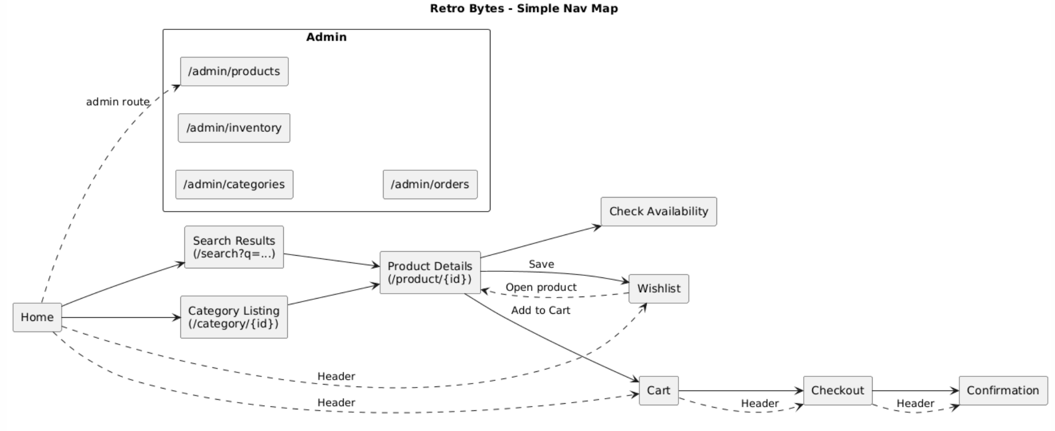
Figure 4 Simple Navigation Map

4.4 WireFrames:

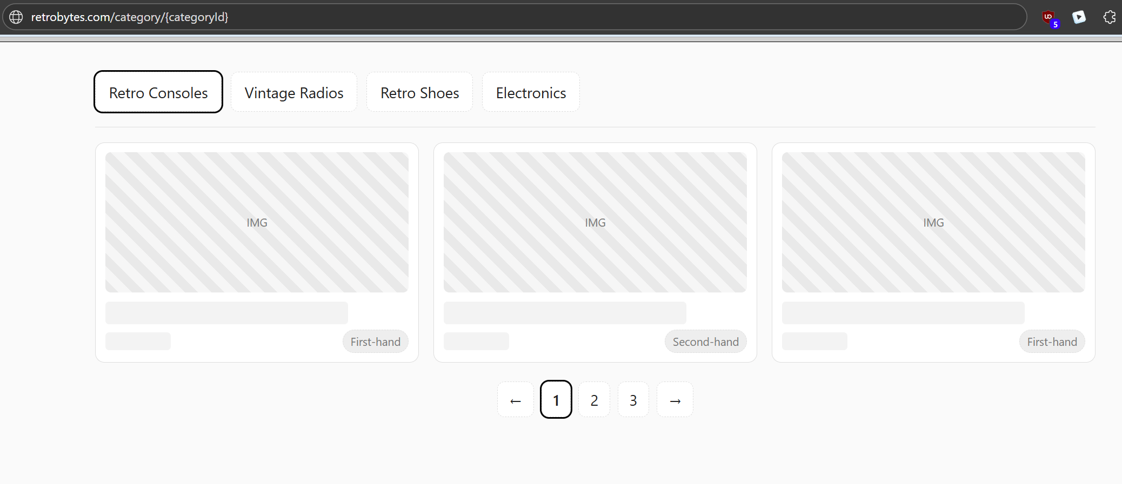
Figure 5 Category Listing

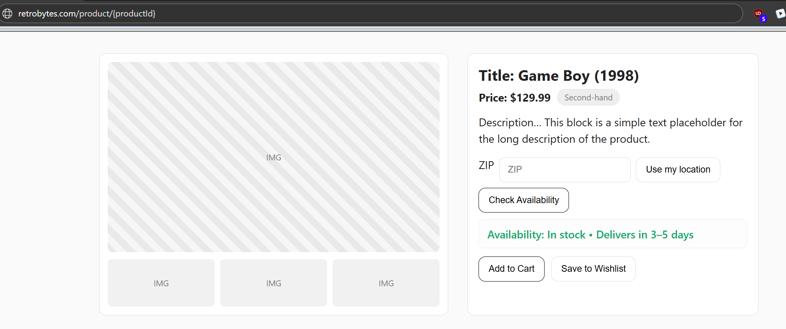
Figure 6 Product Details
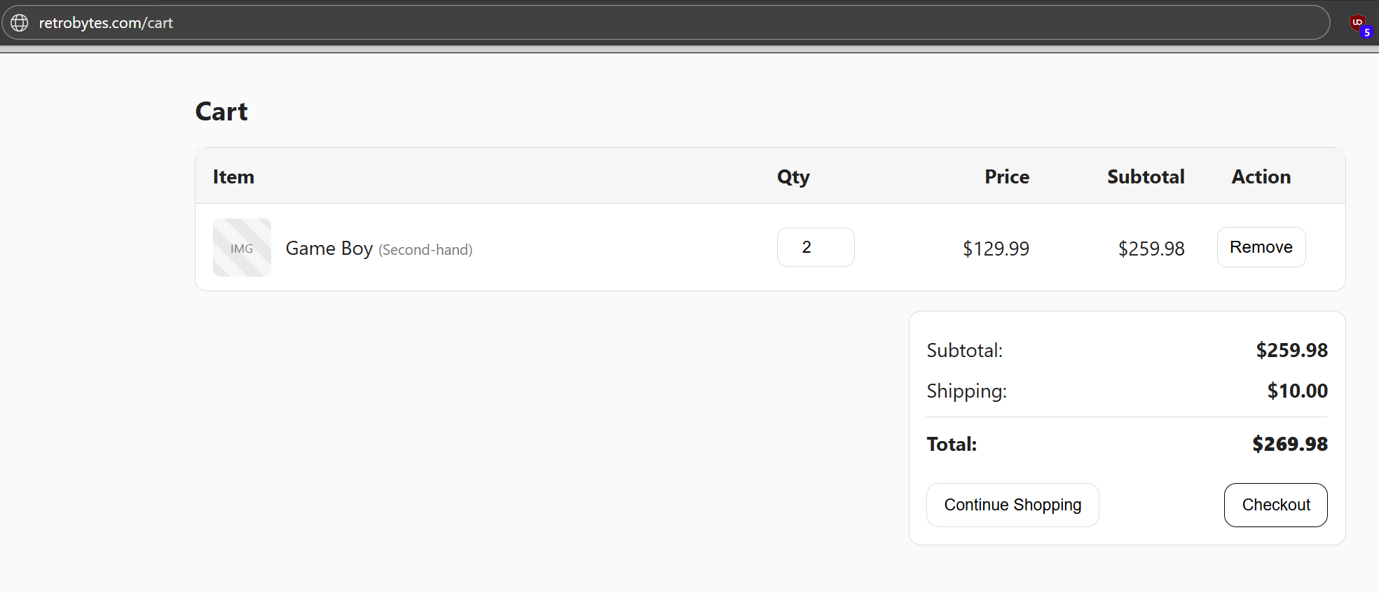
Figure 7 Cart
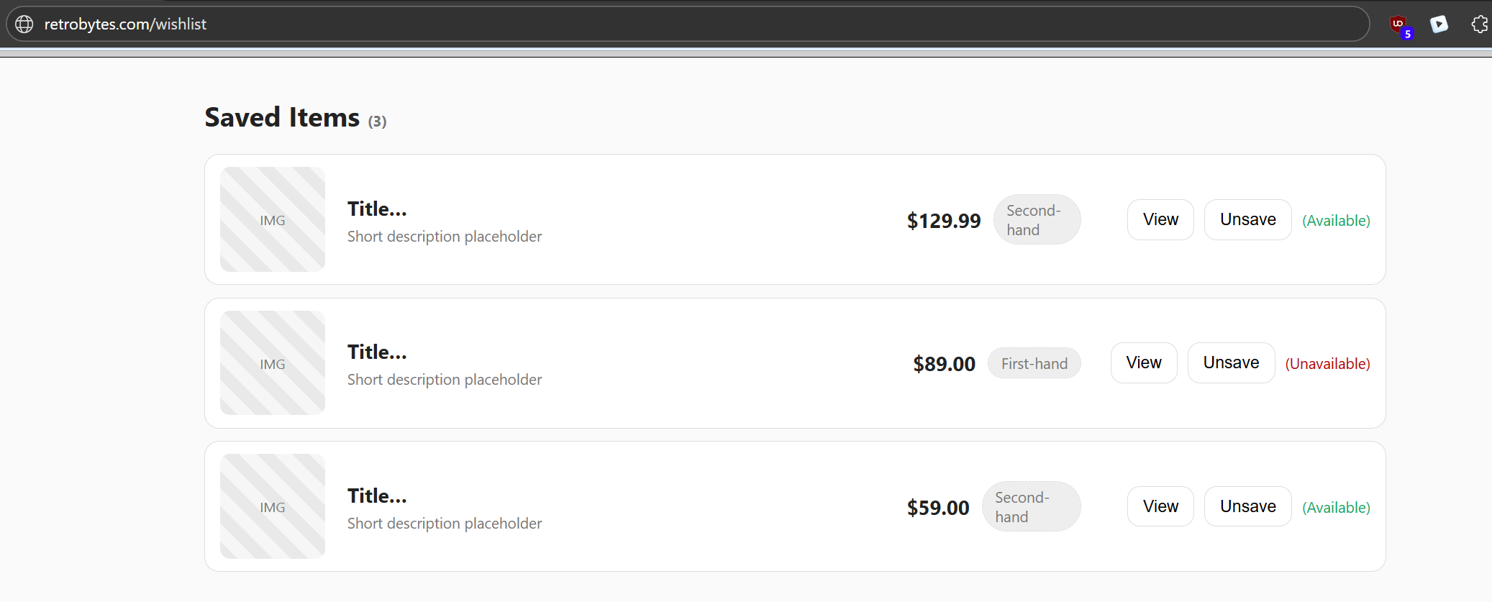
Figure 8 Wishlist
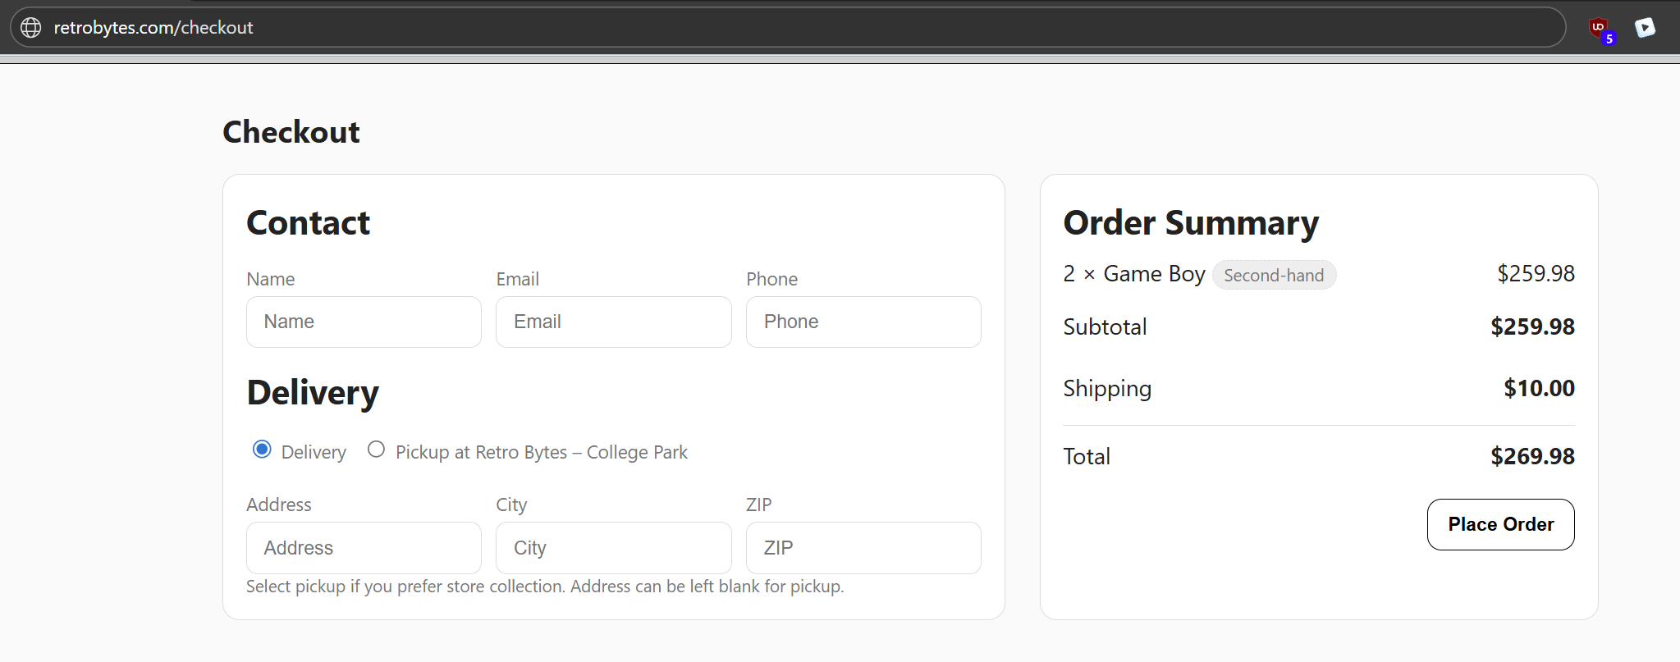
Figure 9 Checkout
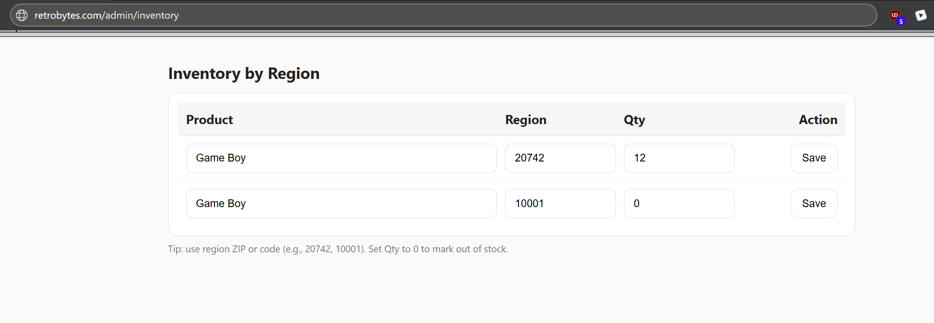
Figure 10 Admin Inventory

5. Application Data Components
5.1 Data to Store:
• Catalog
- Category (name)
- Product (title, description, price, condition = FIRST_HAND | SECOND_HAND, images)
• Inventory (by region)
- productId, regionCode (ZIP/area), qty
• Shopping
- Cart + CartItem (session-scoped)
- Order + OrderItem (placed orders, totals, status)
- Wishlist + WishlistItem (session or user-scoped)
• Media (files)
- Product images stored under /media, file paths referenced from DB
• System
- Simple migrations table for schema versioning
Seed data (for dev/testing)
- Categories: Retro Consoles, Vintage Radios, Retro Shoes, Retro Electronics
- Products: 3 to 5 per category with mixed condition and prices
- Inventory: 2 to 3 regions per product (e.g., 20742, 10001) with varied qty
- Carts / Orders / Wishlist: small sample records for demo
Data rules & lifecycle
- Money: store as integer cents to avoid float rounding.
- Sessions: carts and wishlists expire after 30 days of inactivity .
- Images: write-once, edits create new files, old paths removed from product JSON.
- Orders: immutable rows, cancellations change orders.status only.
- Inventory: Reserve operation (during order) deducts from inventory.qty. if failed, service returns conflict for cart adjustment.

5.2 Core relationships:
1) categories ↔ products
- Cardinality: Category (1) to (N) Products
- Foreign key: products.category_id > categories.id
- On delete: RESTRICT (don’t allow deleting a category that still has products).
- Integrity rules
  - categories.name is case-insensitive UNIQUE (enforced via LOWER(name) index or COLLATE NOCASE).
  - products.condition ∈ {FIRST_HAND, SECOND_HAND}, price >= 0, active ∈ {0,1}.
2) products ↔ inventory
- Cardinality: Product (1) to (N) Inventory rows (one per region/ZIP).
- Composite PK: inventory (product_id, region_code) (fast exact lookups).
- On delete product: CASCADE or RESTRICT (choose one):
  - RESTRICT if you want to prevent removing a product that still has stock rows.
  - CASCADE if removing a product should automatically remove its inventory rows.
• Integrity rules
- qty >= 0.
- region_code normalized to a consistent format (e.g., 5-digit ZIP uppercase).
- Availability status (IN /OUT) is derived in the service layer from qty (e.g., LOW if 0 < qty < 5).
3) carts ↔ cart_items ↔ products
- Cardinality: Cart (1) to (N) CartItem, and Product (1) to (N) CartItem.
- Keys: cart_items (cart_id, product_id) composite PK, FK to products.id.
- On delete product: RESTRICT (prefer not to orphan a cart item) or SET NULL (if you keep historical lines).
4) orders ↔ order_items ↔ products
- Cardinality: Order (1) to (N) OrderItem. Product (1) to (N) OrderItem.
- Denormalization: store order_items.price and order_items.condition to keep a stable snapshot.
5) wishlists ↔ wishlist_items ↔ products
- Cardinality: Wishlist (1) to (N) WishlistItem. Product (1) to (N) WishlistItem.
- Behavior: If a product becomes inactive, mark entry as Unavailable in UI (do not drop automatically).

5.3 Data lifecycle & flows:
- Create category > add products
  - Insert category, then products referencing it.
  - If you must rename a category, it’s safe (FK by id).
- Add/adjust inventory for a region
  - Upsert inventory (product_id, region_code, qty).
  - No derived fields in DB; services compute status on the fly.
- Deactivate a product (products.active = 0)
  - It no longer appears in lists/search, but history (e.g., orders) stays intact.
  - Inventory rows can remain (ignored by UI) or be cleaned by admin job.

5.4 Logical Schema Overview:
Table: categories
- id PK
- name UNIQUE NOT NULL (case-insensitive uniqueness)
- created_at NOT NULL
- updated_at NOT NULL
Indexes
- idx_categories_name_nocase unique on LOWER(name) (or COLLATE NOCASE)

Table: products
- id PK
- category_id FK > categories.id NOT NULL (ON DELETE RESTRICT)
- title NOT NULL
- description NULL
- condition NOT NULL (FIRST_HAND | SECOND_HAND)
- price NOT NULL (decimal/num)
- images_json NULL (JSON array of image paths)
- created_at NOT NULL
- updated_at NOT NULL
- active NOT NULL (boolean, default TRUE)
Constraints
- CHECK (condition IN ('FIRST_HAND','SECOND_HAND'))
- Price ≥ 0 (via CHECK (price >= 0))
Indexes (common queries)
- idx_products_category on category_id
- idx_products_title on LOWER(title)
- idx_products_condition on condition
- idx_products_created_at on created_at
Search
- Start with LIKE over LOWER(title) and LOWER(description); combine with filters on category_id and condition.
Table: inventory
- product_id FK > products.id NOT NULL (part of PK)
- region_code NOT NULL (part of PK; ZIP/region string)
- qty NOT NULL (integer, default 0)
- updated_at NOT NULL
Primary Key
- (product_id, region_code)
Indexes
- idx_inventory_product on product_id
- idx_inventory_region on region_code
Notes
- Use this for UC-2 availability (IN_STOCK/LOW_STOCK/OUT_OF_STOCK computed from qty thresholds in service logic).

5.5 Data Dictionary:
Table Name: Categories
Field | Notes | Type
Category ID | Unique identifier for each category | INTEGER
Name | Display name of the category | VARCHAR
CreatedAt | When the category was created | DATETIME
UpdatedAt | When the category was last updated | DATETIME
Table Name: Products
Field | Notes | Type
Product ID | Unique identifier for each product | INTEGER
Category ID | FK > categories.Category ID | INTEGER
Title | Product title | VARCHAR
Description | Long description | TEXT
Condition | FIRST_HAND or SECOND_HAND | VARCHAR
Price | Unit price | NUMERIC
ImagesJSON | JSON array of image paths under /media | TEXT
CreatedAt | When the product was created | DATETIME
UpdatedAt | When the product was last updated | DATETIME
Table Name: Inventory
Field | Notes | Type
Product ID | FK > products.Product ID (part of PK) | INTEGER
Region Code | ZIP/region identifier (part of PK) | VARCHAR
Qty | Quantity available in that region | INTEGER
UpdatedAt | Last update time for this row | DATETIME
Table Name: Carts
Field | Notes | Type
Cart ID | Unique identifier for the cart | INTEGER
Session ID | Anonymous session key for user | VARCHAR
UpdatedAt | When the cart was last updated | DATETIME

Table Name: Cart items
Field | Notes | Type
Cart ID | FK > carts.Cart ID (part of PK) | INTEGER
Product ID | FK > products.Product ID (part of PK) | INTEGER
Qty | Quantity of this product in the cart | INTEGER
PriceAtAdd | Unit price captured at add time | NUMERIC
CreatedAt | When the item was added | DATETIME
UpdatedAt | When the item was last updated | DATETIME
Table Name: Orders
Field | Notes | Type
Order ID | Unique identifier for the order | INTEGER
Session ID | Copied from the cart/session at checkout | VARCHAR
Region Code | Delivery/pickup region | VARCHAR
Total | Grand total for the order | NUMERIC
Status | PLACED, PENDING, or CANCELED | VARCHAR
CreatedAt | When the order was created | DATETIME
Table Name: Order Items
Field | Notes | Type
Order ID | FK > orders.Order ID (part of PK) | INTEGER
Product ID | FK > products.Product ID (part of PK) | INTEGER
Qty | Quantity ordered | INTEGER
Price | Unit price at order time | NUMERIC
Condition | Denormalized condition for receipts | VARCHAR
Table Name: Wishlist
Field | Notes | Type
Wishlist ID | Unique identifier for the wishlist | INTEGER
Session ID | Anonymous session key for user | VARCHAR
UpdatedAt | When the wishlist was last updated | DATETIME
Table Name: Wishlist Items
Field | Notes | Type
Wishlist ID | FK > wishlists.Wishlist ID (part of PK) | INTEGER
Product ID | FK > products.Product ID (part of PK) | INTEGER
CreatedAt | When the item was saved | DATETIME

6. Test cases
FR | Test ID | Preconditions | Steps | Expected Result | Pass Criteria
FR-001 Browse by Category | TC-001-A | Category “Retro Consoles” has ≥1 product | Open /category/retro-consoles | Grid shows product cards (thumbnail, title, price, condition) | At least one card renders with all fields
FR-001 Browse by Category | TC-001-B | Category exists with 0 products | Open /category/empty-cat | “No items in this category yet” + link to categories | Empty-state text visible; link navigates to categories
FR-002 Product Details | TC-002-A | Product gbc-001 exists | Open /product/gbc-001 | Gallery, title, price, condition badge shown | All fields present; at least one image displays
FR-002 Product Details | TC-002-B | Nonexistent product id | Open /product/does-not-exist | Message “This item is no longer available” + back link | Message visible; back link works
FR-003 ZIP Validate | TC-003-A | On product page | Enter 20742 → click Check | Input accepted; request sent | No inline error; availability request fires
FR-003 ZIP Validate | TC-003-B | On product page | Enter ABC → click Check | Inline validation error | “Enter a valid ZIP/postal code” shown; no request sent
FR-004 Availability | TC-004-A | qty>5 for region 20742 | Call /api/v1/availability?productId=gbc-001&region=20742 | JSON status=IN_STOCK, ETA optional | Status IN_STOCK; UI banner enables Add to Cart
FR-004 Availability | TC-004-B | qty=0 for region 10001 | Same endpoint with region=10001 | JSON status=OUT_OF_STOCK | Status OUT_OF_STOCK; Notify me/nearby options shown
FR-005 Cart Add/Adjust | TC-005-A | Product IN_STOCK | Click Add to Cart | Cart shows line with qty=1; totals update | Item present; subtotal/total correct for qty=1
FR-005 Cart Add/Adjust | TC-005-B | Cart has item; limited stock=2 | Set qty=99 in cart | Qty capped to 2; message shown | Qty equals 2; “Quantity reduced…” message displayed
FR-006 Checkout Form | TC-006-A | Cart has ≥1 item | Open /checkout, fill all required fields | Place Order button enabled | Validation passes; button enabled
FR-006 Checkout Form | TC-006-B | Cart has ≥1 item | Leave ZIP empty; try submit | Inline error near ZIP; blocked submit | Error text visible; cannot submit
FR-007 Place Order | TC-007-A | Valid form; stock available | Click Place Order | Confirmation page with orderId; summary matches cart | orderId visible; items/totals correct
FR-007 Place Order | TC-007-B | Stock lowered concurrently | Click Place Order | Conflict message; cart updated to available qty | Cart reflects new qty; user prompted to review
FR-008 Search | TC-008-A | Products matching “game boy” exist | Open /search?q=game%20boy | Results list + count | ≥1 result; count > 0
FR-008 Search | TC-008-B | No matches for “unobtanium” | Open /search?q=unobtanium | “No matches—clear filters or try a different keyword.” | Empty state text visible
FR-009 Filters | TC-009-A | Search results exist | Apply Category=Retro Consoles; Condition=SECOND_HAND | Filtered results + updated count | All items match both filters
FR-009 Filters | TC-009-B | Both conditions deselected | Deselect both conditions | Prompt “Select at least one condition.” | Submission blocked until one selected
FR-010 Wishlist | TC-010-A | Product detail open | Click Save | Button toggles to Saved; wishlist count +1 | Toast “Item saved”; GET /wishlist includes product
FR-010 Wishlist | TC-010-B | Item already saved | Click Save again | No duplicate entry | Wishlist shows only one entry for the product

7. Traceability
FR ID | Use Case | Handlers (Presentation) | Services (Business) | Repositories (Data) | UI Pages / Screens | Primary API Endpoints
FR-001 | UC-1 Browse Catalog | CategoryHandler | CatalogService | CategoryRepo, ProductRepo | Home/Categories, Category Listing | GET /api/v1/categories, GET /api/v1/products?category={id}&page&sort
FR-002 | UC-1 Browse Catalog | ProductHandler | CatalogService | ProductRepo | Product Details | GET /api/v1/products/{productId}
FR-003 | UC-2 Check Stock | InventoryHandler | — (client validation), InventoryService (server validation) | —, InventoryRepo | Product Details (availability widget) | GET /api/v1/availability?productId={id}&region={zip}
FR-004 | UC-2 Check Stock | InventoryHandler | InventoryService | InventoryRepo | Product Details (availability banner) | GET /api/v1/availability?productId={id}&region={zip}
FR-005 | UC-3 Cart & Order | CartHandler | CartService | CartRepo, ProductRepo, InventoryRepo (for caps) | Product Details (Add), Cart | GET/POST /api/v1/cart, PATCH /api/v1/cart/items/{productId}, DELETE /api/v1/cart/items/{productId}
FR-006 | UC-3 Cart & Order | CartHandler, OrderHandler | CartService, OrderService | CartRepo, ProductRepo | Checkout | GET /api/v1/cart
FR-007 | UC-3 Cart & Order | OrderHandler | OrderService (+ InventoryService reserve) | OrderRepo, InventoryRepo, CartRepo | Order Confirmation | POST /api/v1/orders, GET /api/v1/orders/{orderId}
FR-008 | UC-4 Search & Filter | SearchHandler (can live in Catalog) | CatalogService (search) | ProductRepo | Search Results | GET /api/v1/search?q&category&condition&page&sort
FR-009 | UC-4 Search & Filter | SearchHandler | CatalogService | ProductRepo | Search Results (filters panel) | GET /api/v1/search?q&category&condition&page&sort
FR-010 | UC-5 Wishlist | WishlistHandler | WishlistService | WishlistRepo, ProductRepo | Product Details (Save), Wishlist | GET /api/v1/wishlist, POST /api/v1/wishlist, DELETE /api/v1/wishlist/{productId}
FR-011 | Admin Products (CRUD) | AdminHandlers.Products | CatalogService | ProductRepo | Admin: Products (list/create/edit) | POST /api/v1/admin/products, PATCH /api/v1/admin/products/{id}, DELETE /api/v1/admin/products/{id}
FR-012 | Admin Categories (CRUD) | AdminHandlers.Categories | CatalogService | CategoryRepo | Admin: Categories | POST /api/v1/admin/categories, PATCH /api/v1/admin/categories/{id}, DELETE /api/v1/admin/categories/{id}
FR-013 | Admin Inventory (by region) | AdminHandlers.Inventory | InventoryService | InventoryRepo, ProductRepo | Admin: Inventory | PUT /api/v1/admin/inventory
FR-014 | Admin Orders (read-only) | AdminHandlers.Orders | OrderService | OrderRepo | Admin: Orders list/detail | GET /api/v1/admin/orders?status=..., GET /api/v1/admin/orders/{orderId}
FR-015 | Admin Cancel (pre-fulfillment) | AdminHandlers.Orders | OrderService | OrderRepo | Admin: Order detail (Cancel button) | PATCH /api/v1/admin/orders/{orderId} (e.g., {status:"CANCELED"})

8. References
[1] IEEE Software Requirements Specification (IEEE Std 830-1998). Available: https://ieeexplore.ieee.org/stamp/stamp.jsp?tp=&arnumber=720574. Accessed: Sep. 28, 2025.
[2] IEEE Recommended Practice for Software Design Descriptions (IEEE Std 1016-2009). Available: https://ieeexplore.ieee.org/stamp/stamp.jsp?tp=&arnumber=741934. Accessed: Sep. 28, 2025.

